# Badly Drawn One Button platform game level.

# Deadline: Thursday 29th Feb @ 3 pm

**Draft: will change**

Use the platform game in Lectures.doc as a starting point.

Change the level data so that the data is shown horizontally in the code, matching what will be on the screen.

**(10 %)**

Add and goal tile. (level complete when goal is reached)

Add at least 2 more tile types.

**(10 %)**

**Part 2**

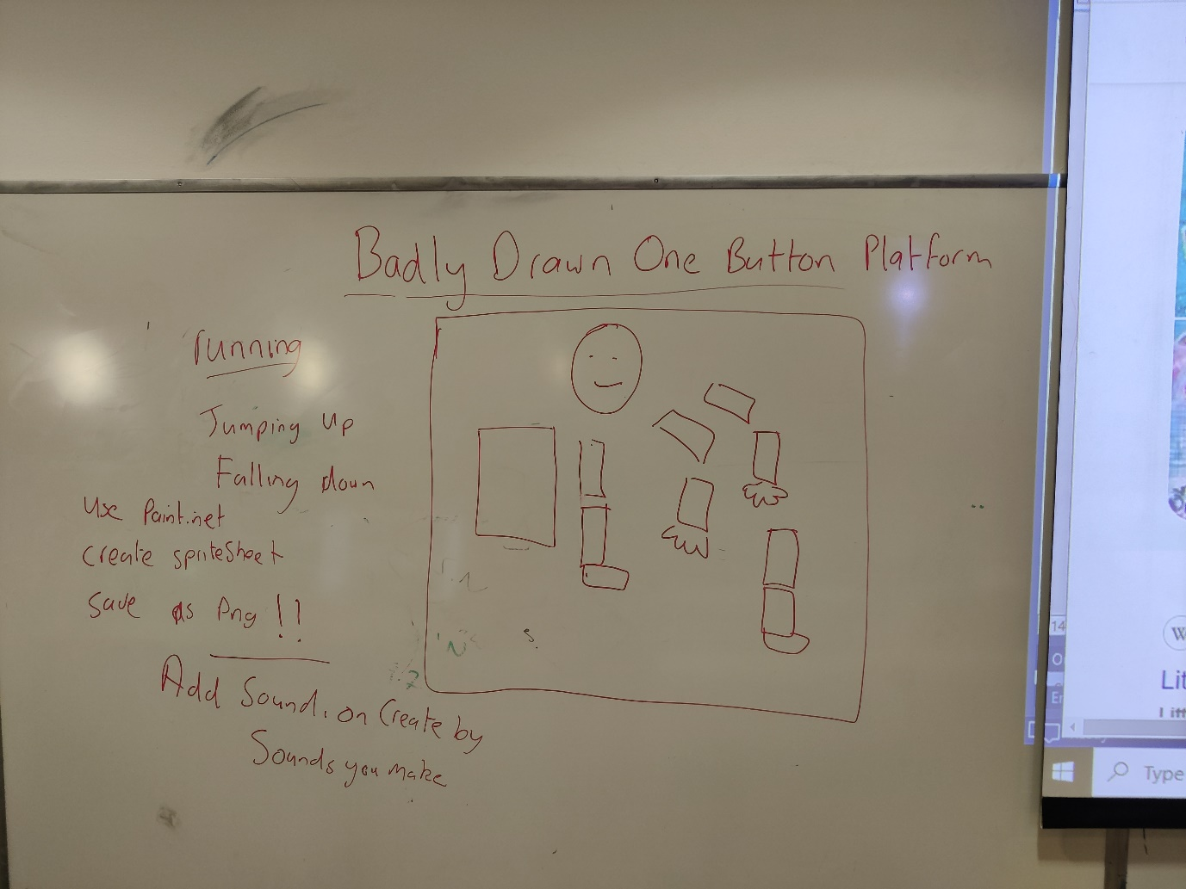

Replace rectangles with sprites.

All sprites must be hand drawn. Draw the body and limbs of your character on paper as above. Cut out the body and limbs. For each animation frame arrange them in a pose and take a photo of them. Copy the image to computer, remove the background ( https://www.remove.bg/ ) repeat for each animation frame. Add frame to a sprite sheet image.

Using the running stickman frames as reference.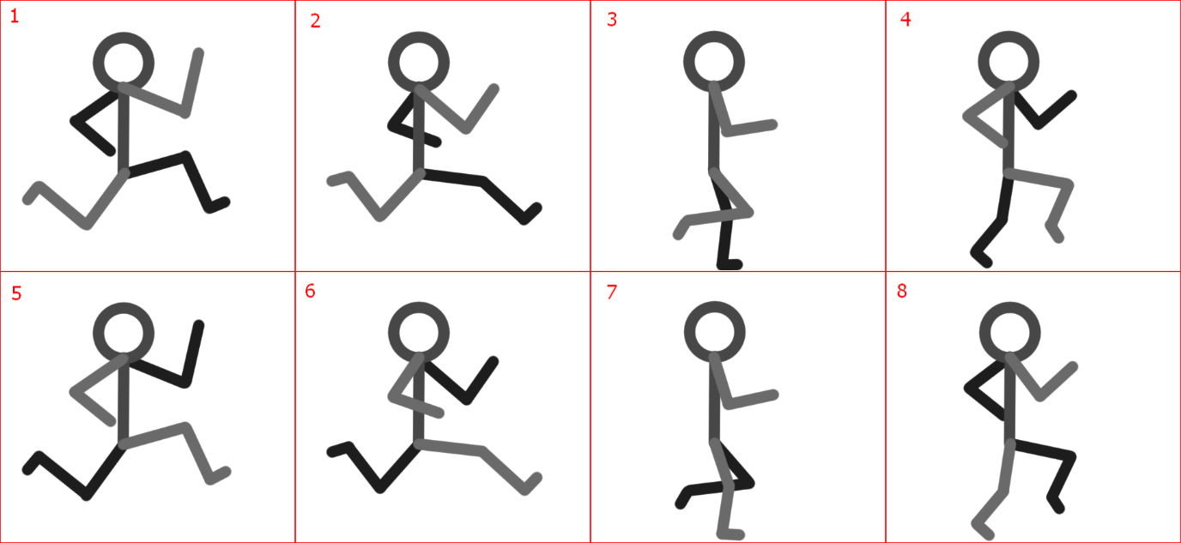

Add a jumping and falling animation.

Draw the tiles also on paper.

**(40%)**

**Sound:**

Sound Effects and narration or vocals. All sounds in the game must be create with your voice.

**(10 %)**

Design the level so that it is a playable game. Require the player to have a level of skill to pass the level.

**(10 %)**

Extra Features:

Examples;

Another Level.

More animations

Extra animated characters ( walking on platforms)

**(20%)**